Airport Data Analysis Project
SQL-Based Analysis of Flight, Airport, and Population Data

Problem Statement
Air travel is a key component of global connectivity and economic development. However, understanding the patterns of airport usage, including passenger flow and route popularity, remains a complex challenge. This project analyzes airport and flight data to uncover trends in passenger volume, flight frequency, and how city population impacts airport operations, with the goal of supporting airport planning, route optimization, and policy-making.
Data source: BTS T-100 Domestic Market (All Carriers) dataset — approximately 19,900 flight records covering airline, airport, route, and passenger/freight/mail statistics.

Database Schema
The data was normalized into four relational tables:
Table | Purpose
AIRPORT | Airport ID, code, city, and state — one row per unique airport
AIRLINE | Airline ID, carrier code, and carrier name
FLIGHT | One row per flight record — passengers, freight, mail, distance, origin/destination airport IDs, and time fields
CITY_POP | City name and population, used to study population's effect on air traffic

FLIGHT intentionally does not store city names or airport codes directly — these are retrieved via JOIN to AIRPORT, avoiding redundant storage (3NF normalization).
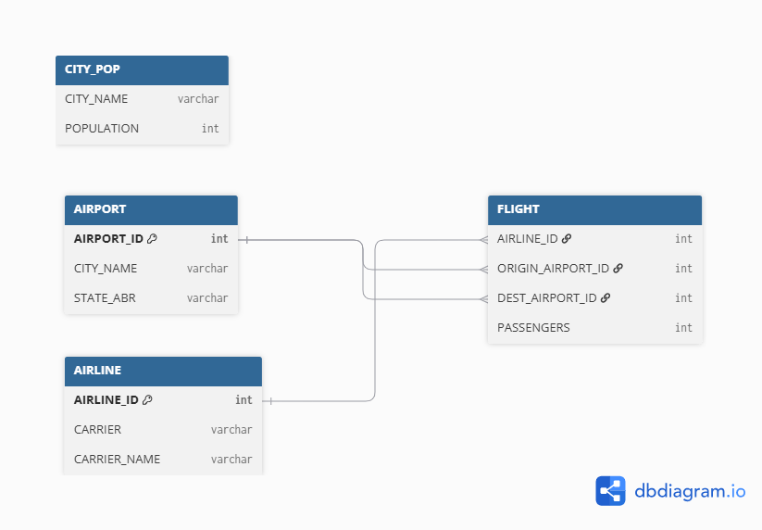

Objective 1: Total Passenger Traffic per Route and Over Time
Top 10 busiest routes, Q1 2025:
Origin | Destination | Total Passengers
Miami, FL | New York, NY | 156,277
New York, NY | Miami, FL | 149,209
Orlando, FL | New York, NY | 130,145
New York, NY | Orlando, FL | 125,937
New York, NY | Chicago, IL | 121,251
New York, NY | Atlanta, GA | 119,729
Atlanta, GA | New York, NY | 118,629
Chicago, IL | New York, NY | 116,245
Orlando, FL | Atlanta, GA | 108,838
Fort Lauderdale, FL | New York, NY | 108,414
Findings: New York dominates domestic air travel, anchoring 9 of the top 10 busiest routes, with over 1.25 million passengers flying on NY-centric corridors in Q1 2025.
So What: This concentration is driven by peak winter-season travel to leisure hubs in Florida (Miami, Orlando, Fort Lauderdale) and major metro hubs (Chicago, Atlanta). Such heavy, concentrated throughput puts real pressure on terminal and airside capacity at New York airports.
Recommendation: New York airports should prioritize terminal and airside modernization to handle this concentrated throughput, and upgrades should extend to partner airports at the other end of these routes, since capacity improvements cannot happen in isolation.

Objective 2: Average Passengers per Flight (Routes and Airports)
Top 5 routes by average passengers per flight:
Origin | Destination | Avg Passengers
Salt Lake City, UT | Atlanta, GA | 40,632
Charlotte, NC | Raleigh/Durham, NC | 38,624
Orlando, FL | Dallas, TX | 30,432
Dallas/Fort Worth, TX | Santa Ana, CA | 29,700
Santa Ana, CA | Dallas/Fort Worth, TX | 29,689
Top 5 airports by average passengers (inbound + outbound combined):
City | Avg Passengers
Hilo, HI | 16,147
Atlanta, GA | 15,974
Orlando, FL | 13,775
Honolulu, HI | 13,341
Denver, CO | 13,116
Findings: Looking at average passengers per flight, rather than yearly totals, identifies routes where planes run consistently full, not just routes with the highest total volume. At the airport level, this metric produces a different ranking than total-traffic — Hilo, HI ranks #1 despite being a small city, ahead of Atlanta.
So What: These top routes likely stay full because they connect major leisure destinations and business hubs: Orlando (theme parks), Salt Lake City-Atlanta (major connecting hub), Charlotte-Raleigh/Durham (business and research corridor), and Dallas-Santa Ana (leisure and business mix). Hilo's top ranking suggests tourism keeps its limited flights consistently full, rather than reflecting overall traffic volume the way Atlanta's does.
Recommendation: Airlines should prioritize routes with consistently high average loads for larger aircraft or added frequency — total-volume rankings alone can hide routes that are reliably full every flight. Smaller high-average airports like Hilo should be prioritized for smoother boarding processes given their near-full flights.

Objective 3: Flight Frequency and High-Traffic Corridors
Top 5 corridors by flight frequency:
Origin | Destination | Flight Frequency
Seattle, WA | Los Angeles, CA | 16
Dallas/Fort Worth, TX | Houston, TX | 15
New York, NY | Chicago, IL | 14
Los Angeles, CA | Seattle, WA | 14
Las Vegas, NV | Los Angeles, CA | 13
Findings: These are the top corridors by number of flights run, led by Seattle-Los Angeles and Dallas/Fort Worth-Houston.
So What: New York-Miami — the #1 route by total passengers (Objective 1) — does not appear in this top-5 list at all, even though New York-Chicago does. This shows frequency and passenger volume are not the same thing: high-frequency corridors here are largely West Coast and short-haul Texas routes, likely running smaller, more frequent flights rather than fewer large ones.
Recommendation: For high-frequency, short-haul corridors like Seattle-LA and DFW-Houston, airlines should ensure aircraft size matches steady demand rather than over-relying on frequency alone. For high-volume but lower-frequency routes like NY-Miami, adding flights — not just larger aircraft — could better balance passenger load.

Objective 4: Top-Performing Origin Airports by Passenger Volume
City | Total Passengers (Origin)
Atlanta, GA | ~3.1M
Denver, CO | ~2.7M
Dallas-Fort Worth, TX | ~2.58M
Chicago, IL | ~2.14M
Orlando, FL | ~2.0M
Findings: Atlanta leads by a clear margin as the top origin airport by total passengers, followed by Denver, Dallas-Fort Worth, Chicago, and Orlando.
So What: Atlanta's #1 position lines up with its reputation as one of the world's busiest airports and a major connecting hub. Denver, Dallas-Fort Worth, and Chicago are similarly major business and corporate travel centers, while Orlando's presence reflects strong leisure and tourist demand rather than corporate travel.
Recommendation: As with the busiest routes in Objective 1, these high-volume origin airports should prioritize smoother outbound processes — faster boarding, reduced wait times — since they handle the largest passenger loads and any inefficiency here affects the most travelers.

Objective 5: Seat Capacity and Utilization
Top 5 airlines by average seat utilization (proxy metric):
Carrier | Avg Utilization %
Aerovias Nacl De Colombia | 100.00
Air Charter Scotland Ltd. | 100.00
Brenzil Pty. Ltd. (Brenzil Jet Charter) | 100.00
Air Canada rouge LP | 100.00
ABS JETS A.S | 100.00
Findings: The dataset does not include an actual seat capacity column, so true seat utilization cannot be directly calculated. As a workaround, each airline's single busiest flight was used as a proxy for "capacity," and other flights were compared against it as a percentage.
So What: Because the proxy is each airline's own maximum, the top-ranked airlines naturally cluster near 92-100%. This reflects consistency of passenger load relative to their busiest flight, not true seat occupancy, and cannot be reliably compared across airlines with different aircraft sizes.
Recommendation: To properly assess seat utilization, the dataset would need actual seat capacity per flight (e.g., aircraft type and seat count). Until then, this metric should be treated as a rough consistency indicator, not a capacity-planning figure.

Objective 6: Popular Destination Airports by Inbound Passengers
City | Code | Total Passengers (Inbound)
Atlanta, GA | ATL | 3,126,527
Denver, CO | DEN | 2,714,566
Dallas-Fort Worth, TX | DFW | 2,590,043
Chicago, IL | ORD | 2,199,886
Orlando, FL | MCO | 1,941,202
Findings: The top 5 destination airports by inbound passengers — Atlanta, Denver, Dallas-Fort Worth, Chicago, Orlando — are nearly identical to the top 5 origin airports from Objective 4.
So What: This overlap makes sense: major hub airports handle heavy traffic in both directions, serving as both origin points and connecting destinations for corporate and leisure travel alike. Atlanta, Denver, and Chicago reflect strong business and connecting-hub demand, while Orlando's inbound volume reflects tourism.
Recommendation: Since these airports face high passenger volume both inbound and outbound, infrastructure investment (gates, baggage handling, security throughput) should account for two-directional peak load, not just outbound congestion as noted in Objective 4.

Objective 7: City Population vs. Airport Passenger Traffic
Top cities by traffic-to-population ratio (combined inbound + outbound):
City | Population | Total Traffic | Ratio
Lihue | 7,064 | 280,748 | 39.74
Punta Gorda | 7,748 | 206,504 | 26.65
Kahului | 30,706 | 526,895 | 17.16
Orlando | 307,834 | 3,943,135 | 12.81
Fort Lauderdale | 182,892 | 2,305,398 | 12.61
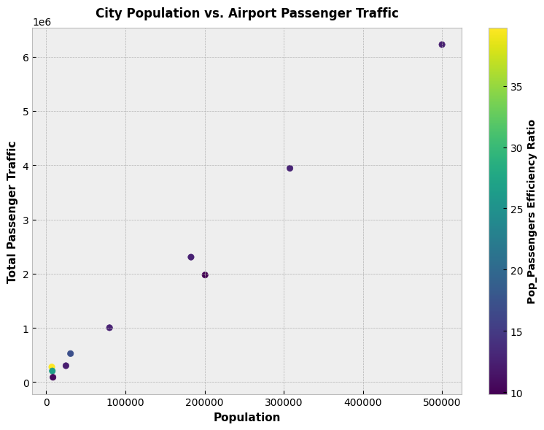
Findings: Combining inbound and outbound traffic per city and plotting against population, the scatter plot shows an overall positive relationship: as population increases, total passenger traffic tends to increase too.
So What: But it is not a strictly linear relationship. Several small-population cities — Lihue, Punta Gorda, Kahului — carry a disproportionately high volume of traffic relative to their size, almost certainly because they are strong tourist and leisure destinations rather than population centers. Population alone does not fully explain traffic; destination appeal matters just as much, especially for smaller cities.
Recommendation: Airport capacity planning should not rely on population size alone. Small cities that are popular travel destinations, like Lihue, may need infrastructure investment disproportionate to their population, since traffic demand there is driven by tourism, not local population size.

Objective 8: Impact of Population Size on Flight Frequency and Route Choices
Origin population vs. flight frequency:
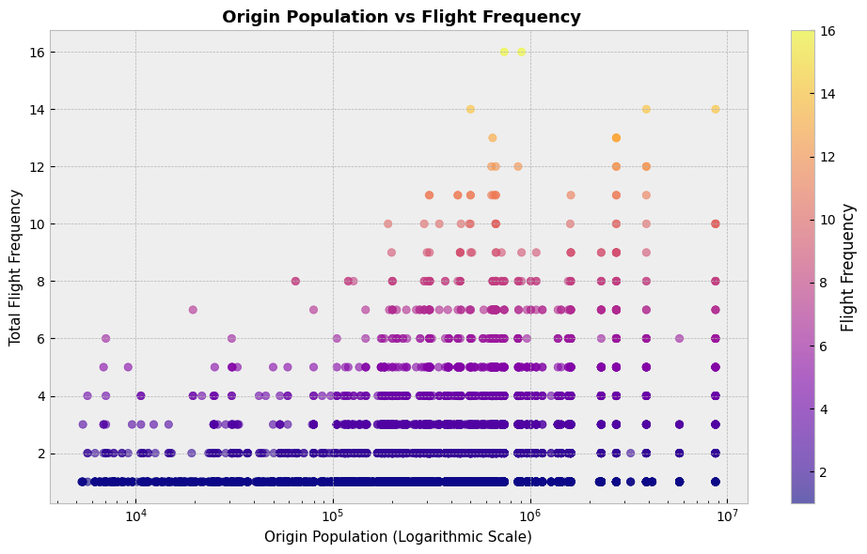
Destination population vs. flight frequency:
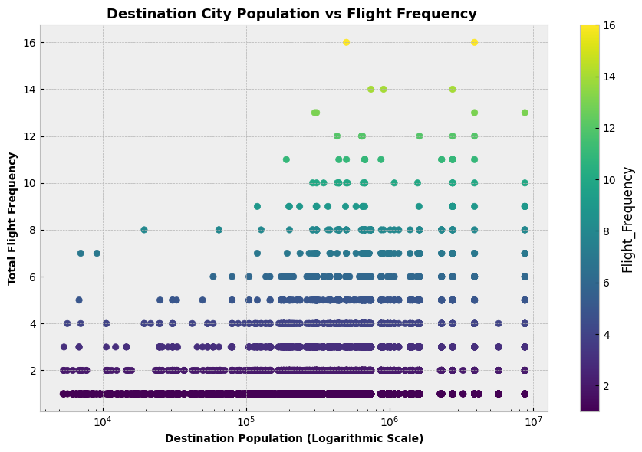
Findings: Plotting population against flight frequency for both origin and destination cities shows that, overall, higher population in both cities tends to align with higher flight frequency.
So What: It is not a strictly linear relationship — there are also many cases where origin and destination population are both low, yet flight frequency is still high. Large population supports high-frequency routes, but it is not the only driver; other factors such as tourism, business demand, and hub status can push frequency up even for smaller cities.
Recommendation: Route planners should not rely on population size alone to predict or justify flight frequency. Some low-population city pairs already sustain high-frequency service, likely due to non-population factors — these cases are worth studying individually rather than assuming small cities need less frequent service by default.

Data Cleaning & Challenges
Real-world data required a couple of non-obvious fixes during analysis:
Multi-airport cities (New York, Houston, etc.): Aggregating traffic by airport before joining to city-level population data caused the same city to appear multiple times with inflated totals. Fixed by summing traffic to one row per city before joining population.
City name string-splitting bug (Dallas/Fort Worth): An overly broad string-cleaning step meant to strip country suffixes accidentally merged "Dallas/Fort Worth" into "Dallas," colliding two distinct metro areas. Fixed by narrowing the string-split logic.

Limitations
• No seat capacity/seats column exists in the source data, so seat utilization (Objective 5) could not be directly measured and was approximated using a proxy metric.
• Objective 7 is limited to the small number of cities with matching population data (10 cities), since population data is not available for every airport city in the dataset.

Conclusion
1. Population and traffic are related, but not simply. Bigger cities generally see more passenger traffic and more flights (Objectives 7, 8). But it is not a straight line — some small cities carry surprisingly heavy traffic because they are popular destinations, not because they are big.
2. A few major hubs dominate both directions. Atlanta, Denver, Chicago, and Dallas-Fort Worth show up again and again as top origin and destination airports (Objectives 1, 4, 6). These hubs carry the heaviest overall load.
3. Totals can hide the real story. Looking at averages and frequency, not just total passengers, revealed different patterns — some routes fly often but carry fewer passengers per flight, and some small airports have very consistent, full flights (Objectives 2, 3).
4. Recommendation for airport planning. Prioritize infrastructure at the major hubs, but do not plan based on population alone — smaller destination cities can need investment disproportionate to their size.

